

Project Report
LetsRyde – Ride Booking System in Java

Submitted by:
Atika Nasir
(FA24-BSE-129)
Course Title:
Object Oriented Programming
Submitted to:
Sir Shehzad Ali

1. Project Title
LetsRyde – Ride Booking System in Java
2. Introduction
The LetsRyde project is a simplified ride-booking system implemented in Java using Object-Oriented Programming (OOP) concepts and GUI design with Swing.
It allows a rider to:
- Log in
- Select a driver
- Enter ride details (origin, destination, distance)
- Book a ride and calculate fare
- View ride history saved in a file
This project demonstrates the use of OOP principles, file handling, and event-driven GUI programming.
3. Objectives
- Implement OOP concepts: inheritance, encapsulation, abstraction, and association.
- Design a user-friendly GUI for booking rides.
- Maintain a persistent ride history using file handling.
- Simulate a small-scale ride-hailing application workflow.
4. Technologies Used
- Java SE 8+
- Swing GUI Toolkit
- IntelliJ IDEA IDE
- File handling for data persistence (rides.txt)
5. Features
User Interface
- Blue-themed GUI for better user experience
Input fields:
- Rider name
- Origin
- Destination
- Distance
Scrollable list of available drivers
Buttons:
- Book Ride
- View History
Ride Booking
- Rider selects driver and inputs ride details
- Fare calculated based on distance and vehicle type
- Ride details saved to rides.txt
Ride History
- View previously booked rides via a popup
- Rides are persistent across program runs
File Handling
- All rides stored in a CSV format (Rider,Driver,VehicleType,Distance,Fare)
- Uses FileWriter and BufferedReader for saving and reading
6. Object-Oriented Design
Rider
- Stores rider information (name).
Driver
- Stores driver information (name, vehicle).
Vehicle
- Abstract class for vehicle types.
Car/Bike
- Concrete subclasses of Vehicle.
Ride
- Represents a booked ride (rider, driver, distance, fare).
FileService
- Handles saving/loading rides to/from a text file.
Main (UI)
- GUI for booking rides and viewing history.
Relationships
- Ride has a Rider and has a Driver (Aggregation)
- Driver has a Vehicle (Aggregation)
- Car and Bike inherit from Vehicle (Inheritance)
- Main depends on Ride, Driver, Rider, FileService
7. Class Diagram
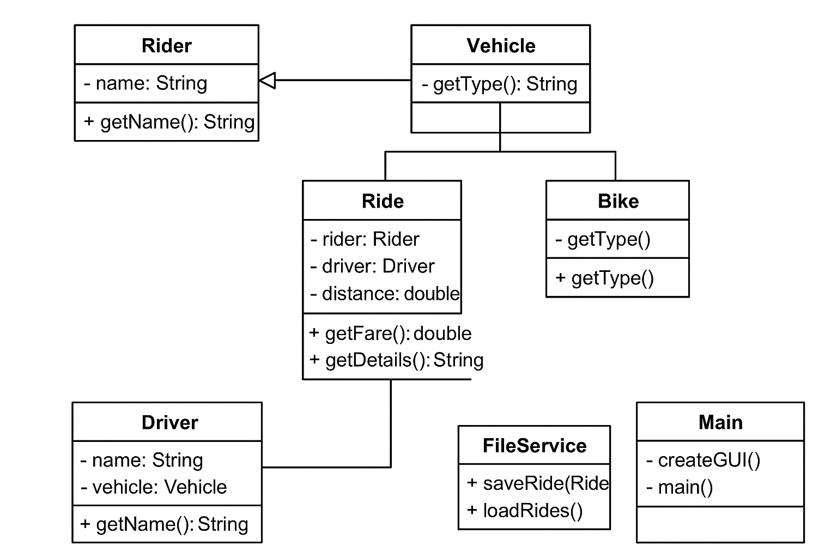
8. Implementation Details
8.1 Rider Class
- Stores rider’s name and provides getter method.
8.2 Driver Class
- Stores driver’s name and assigned vehicle.
8.3 Vehicle Class
- Abstract class with getType() method.
- Car and Bike extend Vehicle.
8.4 Ride Class
- Stores Rider, Driver, and distance.
- Calculates fare: Car = 50/km, Bike = 30/km.
- getDetails() returns a CSV line for file saving.
8.5 FileService Class
- Saves rides to rides.txt using FileWriter.
- Loads rides using BufferedReader.
8.6 Main (UI) Class
- Uses Swing for GUI.
- Blue-themed window with input fields, buttons, and list.
- Book Ride button saves ride, View History button reads and shows rides.
9. File Handling Example
rides.txt format:
Alice,Rahul,Car,12.5,250.0
Bob,Sneha,Bike,5.0,50.0

Code to save ride:
Ride ride = new Ride(rider, driver, distance);
FileService.saveRide(ride);
Code to load rides:
ArrayList<String> rides = FileService.loadRides();
for(String r : rides){
System.out.println(r); }
10. Screenshots
- Login / GUI screen

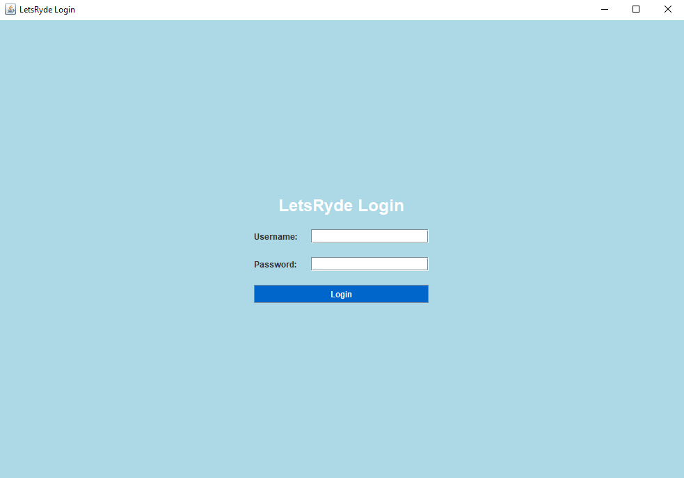
- Booking a ride

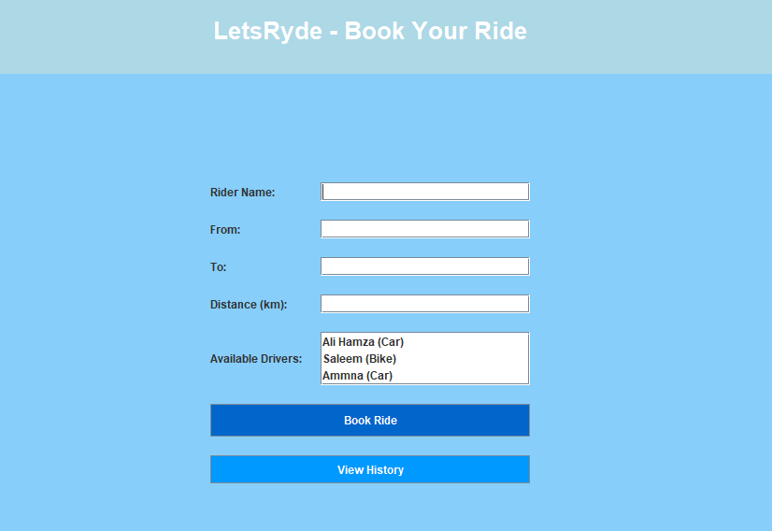

- View ride history popup
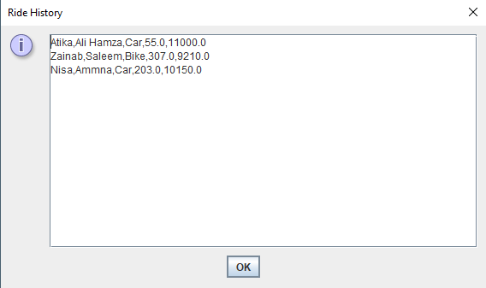
11. Conclusion
The LetsRyde project demonstrates:
- Effective use of OOP concepts: inheritance, aggregation, encapsulation
- Simple file-based persistence
- GUI application with Swing
- Event-driven programming with action listeners
- It can be extended further to:
- Add login and authentication
- Include multiple ride options (e.g., fare discounts, surge pricing)
- Integrate database support instead of text files

12. References
- Oracle Java Tutorials
https://docs.oracle.com/javase/tutorial/
- Java Swing GUI Guide
https://docs.oracle.com/javase/8/docs/technotes/guides/swing/
- File Handling in Java
https://www.geeksforgeeks.org/file-handling-in-java-using-filewriter-filereader/

